**AUTOMATIC ROOM LIGHTNING SYSTEM**

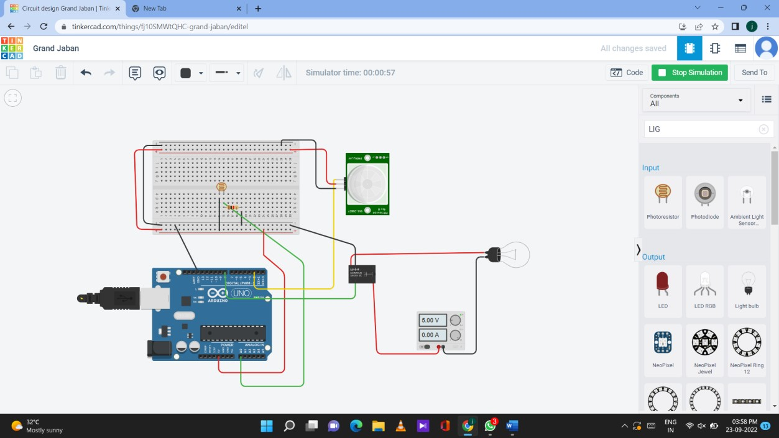

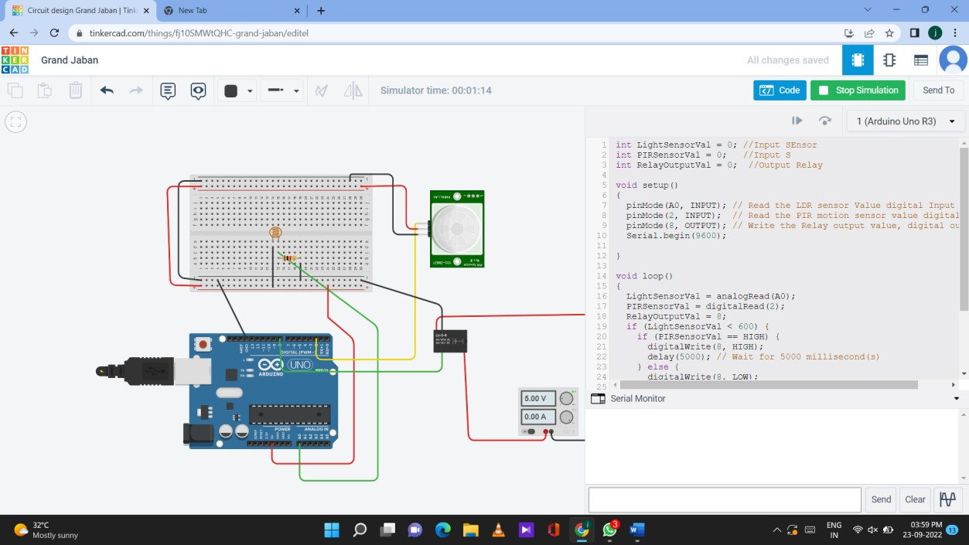

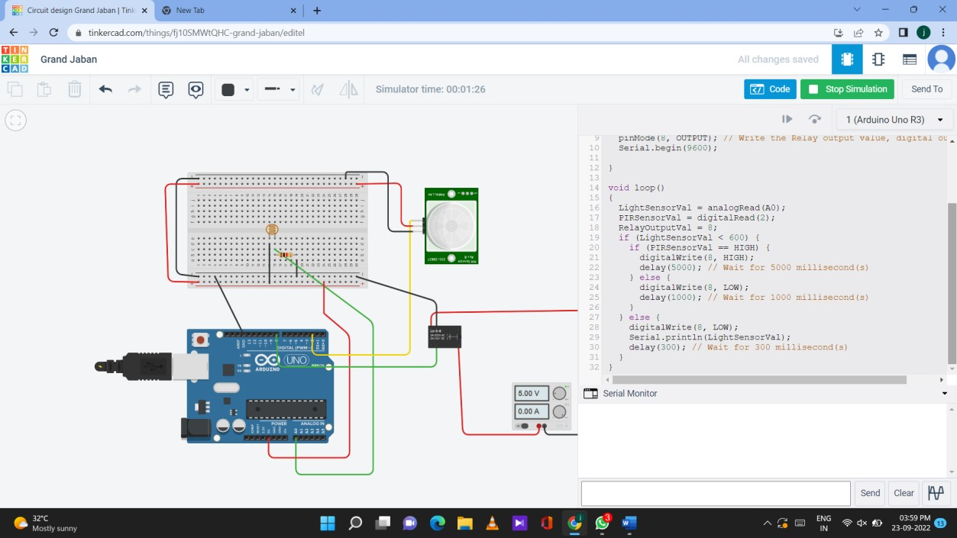

# CODE

int LightSensorVal = 0; //Input SEnsor int PIRSensorVal = 0; //Input S int RelayOutputVal = 0; //Output Relay

void setup()

{

pinMode(A0, INPUT); // Read the LDR sensor Value digital Input pinMode(2, INPUT); // Read the PIR motion sensor value digital Input pinMode(8, OUTPUT); // Write the Relay output value, digital output Serial.begin(9600);

}

void loop()

{

LightSensorVal = analogRead(A0);

PIRSensorVal = digitalRead(2); RelayOutputVal = 8; if (LightSensorVal < 600) { if (PIRSensorVal == HIGH) { digitalWrite(8, HIGH); delay(5000); // Wait for 5000 millisecond(s)

} else { digitalWrite(8, LOW); delay(1000); // Wait for 1000 millisecond(s)

}

} else { digitalWrite(8, LOW); Serial.println(LightSensorVal); delay(300); // Wait for 300 millisecond(s)

}

}